El Wine Chateau Wine Club
August 2014
South African Wines

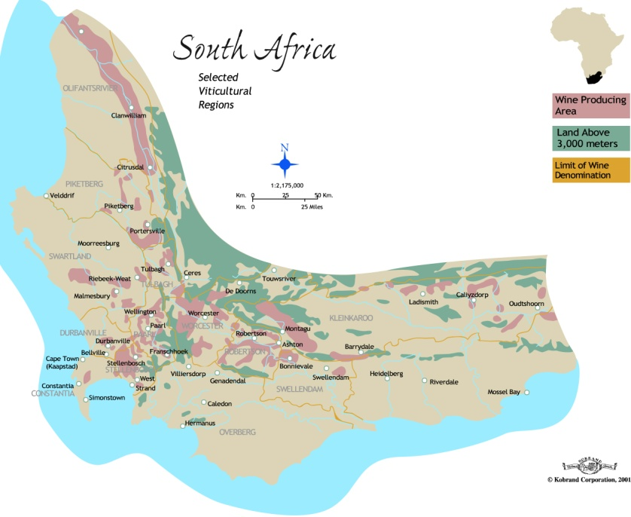
South Africa is one of the most prominent wine-producing countries in the Southern Hemisphere. With more than 300 years of winemaking history, it is often described as bridging the gap between the Old World and New. The majority of wines are made using New World winemaking techniques but often have more in common stylistically with their Old World counterparts. South Africa’s wine industry is distributed around the lush, rugged landscape of the Western Cape. Here, the abundance of mountains, valleys and plateaus allow winemakers to produce a diverse range of styles.
The country's signature variety is Pinotage, a crossing of Pinot Noir and Cinsaut that is rarely found in quantity in any other wine-producing country. Shiraz is widely planted also, as are Cabernet Sauvignon and Merlot (often found together in a Bordeaux Blend). Chenin Blanc is the republic’s most-planted grape. The Wine of Origin system, a legal structure introduced in 1972 to acknowledge and protect the diversity of terroir in the country, classifies South Africa into the regions, districts and wards where vineyards are found.
South Africa’s oldest wine estate is located in Constantia, where the production of the legendary dessert wine Vin de Constance gave the region worldwide fame in the 18th and 19th centuries. Stellenbosch is equally historic as a wine-producing region, the first vineyards having been planted here in the 1690s. The South African wine industry suffered numerous setbacks during the 19th and 20th centuries. A devastating outbreak of phylloxera in the 1860s all but killed off the production of Vin de Constance. Throughout the 20th Century, the South African Co-Operative Wine Growers Association (better known as KWV) restricted the production of wines in such a way that innovation was near-impossible and quantity was prioritized over quality. Its control over the South African wine sector lasted until the 1990s.
South African wine fell out of favor internationally during the 20th Century, reaching an all-time low when trade sanctions were placed on the country in the 1980s due to its apartheid policies. It was Nelson Mandela who helped to reinvigorate the industry: wines from the Rust en Vrede estate in Stellenbosch were served at his 1993 Nobel Peace Prize ceremony dinner in Oslo, Norway.
Today, South Africa is the ninth-largest producer of wine in the world, with some 100,000 hectares (250,000 acres) under vine. More than 250,000 people are employed in the industry and South African wine has enjoyed international attention and acclaim for its wide variety of styles.

Sub-regions of South Africa: The Western Cape is home to the vast majority of the South African wine industry, and the country's two most famous wine regions, Stellenbosch and Paarl. The city of Cape Town serves as the epicenter of the Cape Winelands, a mountainous, biologically diverse area in the south-western corner of the African continent. A wide variety of wines are produced here, from rich, robust reds made from Shiraz and Pinotage to fresh, flinty whites made from Sauvignon Blanc and Chenin Blanc.The Western Cape is littered with spectacular mountain ranges that form the Cape Fold belt. These are extremely important for viticulture across the whole region, contributing soils and mesoclimates ideal for the production of premium wines. Of particular importance are the Boland Mountains, which form the eastern border of the Coastal Region, and the Langeberg range, which separates the Breede River Valley from the Klein Karoo semi-desert. The Hottentot Hollands and the Riversonderend mountains around Elgin and Overberg are also very influential on the wines produced in those regions. The Cederberg Mountains in the north are home to some of South Africa’s highest-altitude vineyards. The dominant soil types in the Western Cape are granite, Malmesbury shale and Table Mountain sandstone. Alluvium and loam soils can be found along the beds of the Breede River, the Berg River, and the Olifants River in the north.Traditionally, the Western Cape is known for its elegant Bordeaux Blends, easy-going Pinotage and honeyed Chenin Blanc. Nowadays, winemakers are experimenting with more international styles. Burgundy-style Pinot Noir and Chardonnay from Walker Bay are making a splash, and cool-climate-style Sauvignon Blanc from Darling and Overberg is rivaling that made in any other New World country.
THE GRAHAM BECK ESTATES

ROBERTSON ESTATE
Graham Beck’s Robertson estate, Madeba, is situated in the breathtaking Breede River Valley bordering the semi-arid Little Karoo region. The farm is located on the famous Route 62, a meandering country road which takes visitors on an unforgettable tour of the region’s plentiful attractions. At our Robertson Cellar we focus on minimal intervention, allowing instead the authentic essence of the fruit and terroir to shine through in the final wine.
Situated 10 km from the charming town of Robertson and only 140 km from Cape Town, the Graham Beck Robertson Cellar is a testimony to the inspired vision and foresight of the Beck family.
In itself a striking and innovative design, this cellar is responsible for producing our distinctive and world class Cap Classique and still wines.

STELLENBOSCH VINEYARDS
Exceptional Terroir, Superb Quality.
Our Skoongesig and Vredenhof vineyards are situated in Firgrove in the prime wine growing region of Stellenbosch’s Helderberg area. The farms are located along the False Bay rim, no more than two kilometers from the ocean. This proximity to the sea ensures a constant cooling breeze, allowing even ripening of the fruit and exceptional quality. They say great wines are made in the vineyard. Nothing could be truer of the superb calibre of fruit from our two premier Stellenbosch sites – highlighting our aim to constantly raise the bar in terms of quality and consistency

INTRODUCING THE GAME RESERVE RANGE
Each cultivar features one of the many indigenous animals and plants found in the Graham Beck Private Nature Reserve on our Robertson Estate. Every wine in the range tells a unique and compelling story, celebrating the splendid natural diversity of this remarkable, yet intensely fragile region.
Supporters of The Game Reserve wines can regard their purchase with pride, knowing that, in addition to investing in a premium quality wine, they are sustaining South Africa’s rare ecology in a tangible way. The logo is a striking depiction of ‘restoring harmony and natural balance’, as expressed in the brand slogan: “Planet first. It’s in our nature”. The overriding circular theme represents the planet, while the sphere is also a potent symbol of re-growth, regeneration, returning cycles, the earth and ecology. Within this circle two main elements are merged: a natural element and a human component.
This exceptional brand conveys a powerful message of holistic synergy and the extraordinary potential we possess to heal our ailing planet through conservation and farming in concert with Mother Nature. It is our hope that these wines will inspire you to join us in our quest to nurture, repair and safeguard our cherished natural legacy.

Brut Rosé N V

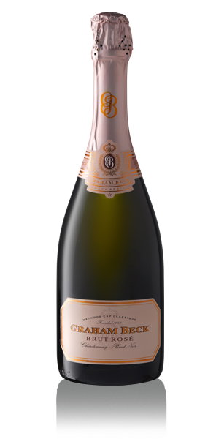
With its charming silver-pink hue and exuberant character this seriously classy Cap Classique ( Method Champenoise) is flirtatious and fun – the quintessential accompaniment to any special occasion, or even just as a special spur of the moment indulgence.
An effortlessly smooth blend of the two classic Cap Classique varieties – Chardonnay and Pinot Noir, sourced from our farms in Robertson and Stellenbosch. In the cellar meticulous attention to detail included whole bunch pressing, ensuring only the finest quality juice was used for fermentation, while the cultivars were fermented separately. A special enzymatic reaction during transport of the Pinot Noir fruit resulted in the stunning pale silver-pink hue of the wine. The Rosé NV was allowed enough time on the lees to develop subtle yeasty undertones but to burst with berry and cherry flavours. On the nose expect whiffs of raspberries, cherries and a few secondary aromas of minerality. The palate delivers a lively mousse but fine in the mouth, with subtle red berry flavours enlivened by bright acids. Showing hints of oyster shell and fresh lavender. Flirtatious and fun, yet elegant and structured, it’s perfect for all seasons and settings. The ultimate in food friendly wines.
“This wine is a consummate all rounder. Most certainly elegant and refined, while simultaneously exuberant and racy,” maintains Pieter Ferreira, Graham Beck cellarmaster.

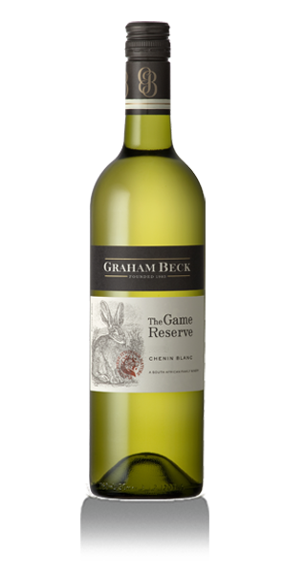
THE GAME RESERVE CHENIN BLANC

The label for this wine features the endangered and highly elusive South African Riverine Rabbit which inhabits the wildlife reserve situated on Graham and Rhona Beck’s Robertson estate, Madeba. The wine celebrates Graham Beck Wines’ commitment to conserving the natural environment.
This 100% Chenin Blanc is from low yielding, 40 - 46 year old bush vines on rolling hills in Paarl, exposed to south eastern winds, rain and lots of sunshine. The grapes were left to ripen fully to ensure the development of the rich and ripe flavours and complexity. The grapes were destalked, then mash cooled with 8-12 hours skin contact and cool fermentation. A small percentage (5-10%) of the Chenin Blanc was fermented in French Oak barrels to generate an added dimension of richness. The complex nose shows upfront tropical fruit, ripe pineapple, melon, peaches and honey flavours, lifted by a citrus element. Good company for al fresco lunches. Also great with grilled chicken or fish, rich pasta dishes and spicy food.
Full and juicy palate with layers of ripe tropical fruit complemented by a long, clean, crisp and lingering aftertaste.

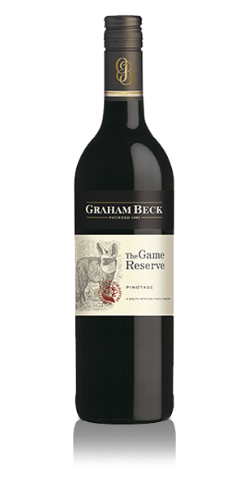
THE GAME RESERVE PINOTAGE

This delightful wine pays tribute to the bat eared fox, a fascinating little creature which feeds mainly on termites. We’re actively trying to conserve this unique species, which is indigenous to our Robertson estate, as they are often falsely identified as jackals and killed – a practice we are striving to halt.
The grapes for this wine were hand harvested from vineyards in Franschhoek, Paarl and Robertson. The wine was fermented in open and closed fermenters with regular punch downs and pump-overs to ensure upfront fruit and soft extraction. It spent 10 months in 3rd and 4th fill barrels with a portion of the blend remaining unoaked. On the nose you’ll encounter ripe cherry, strawberries and plums with ripe red berries and spices on the palate. A full structured and well balanced wine which rewards with a juicy yet elegant mouthfeel and silky tannins.
The perfect partner to slow cooked casseroles, fillet, pastas, robust cheeses or a good old fashioned barbeque.

THE GAME RESERVE SHIRAZ

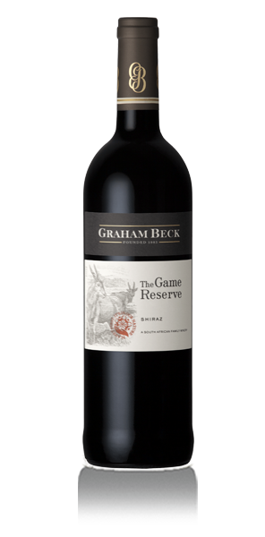
The label for this mouthwatering Shiraz features the majestic eland – Africa’s largest antelope. Due to our conservation efforts we’re able to provide this graceful creature with a perfect natural habitat in which it can continue to thrive.
The fruit for this wine was sourced from our Stellenbosch vineyards. The grapes were handpicked at optimum ripeness and fermented in varying methods of punch down, submerged cap and aerated pump-overs for optimum structure and complexity. It spent 15 months in a combination of 80% French and 20% American oak (1st, 2nd and 3rd fill) barrels. On the nose expect notes of red berries, sweet spices and hints of white pepper. The palate is well balanced and layered with mulberry and black cherry fruit complemented by a spicy freshness. A rich ripe wine with silky tannins, an appealing piquancy and a long, lingering finish.
Absolutely fabulous when teamed with north African dishes, spicy Moroccan food or a lip-smacking casserole.

The Special Wine
KLEINOOD FARM
The de Villiers family has left deep footprints in the history of the South African wine industry through the centuries, and Kleinood and the Tamboerskloof wines are no exception.
The French Huguenot Jacob de Villiers bought the wine farm Boschendal between Stellenbosch and Franschhoek, after immigrating to the Cape of Good Hope in 1688. In the year 2000 Gerard de Villiers, a direct descendant of Jacob, and his wife, Libby, found the piece of land that stole their hearts – complete with mountains, river and a pristine tract of indigenous forest.
They renamed the farm to Kleinood. Kleinood is an Afrikaans word from Dutch and German origin meaning something small and precious. This is exactly what Kleinood means to them and precisely what it is – a small farm, very dear to their hearts, specializing in the produc tion of only a Syrah based red wine, a small production of Viognier. They decided on which cultivars to plant after several years of careful analyses of soil types and climatic conditions on the farm. Thus, not only their passion, but also the terroir, the sun and the rain led them to plant Shiraz, Mourvèdre, Rousanne and Viognier on North and West facing slopes. From this delicate balance between science and passion the Tamboerskloof wines, now cultivated, nurtured, harvested, pressed, matured and bottled with equal care were born.

Before moving to the Boland, Gerard, Libby and their two children, Spicer and Katharien, lived in the Cape Town suburb Tamboerskloof for 25 years. Hence, they decided to call their wine Tamboerskloof. The name Tamboerskloof means the valley (kloof) of the drums (tamboer).

Meticulous care and handling
One of the secrets of the Kleinood wines lies in picking at exactly the right time. Each year the team inspects the vineyards from an aerial perspective. This allows them to do an infrared survey of the vineyards, thus determining vigour and ripeness of different areas in each block. Each area is then picked accordingly.
“The vines and grapes undergo extensive monitoring throughout the year to ensure that we understand our vineyards and learn how to farm them better,” says Gunter. “In this manner we establish the pruning weight of the pruned shoots, the weight of the bunches, the size and weight of the berries etcetera for each block, affording us the opportunity to create the correct balance between terroir, vine and grape,” he explains. Grapes are selected in the vineyards on a regular basis from the start of veraison and as many as five passes are conducted before the grapes are finally picked and brought to the cellar in small picking boxes

TAMBOERSKLOOF SYRAH 2009

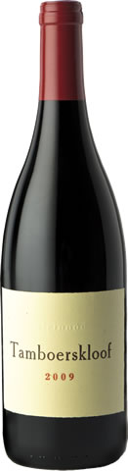
GRAPES : Shiraz 95%, Mourvedere 4% , Viognier 1%.

Hand picked grapes, sorted 3 times before going into stainless steel fermenters where a combination of modern technology and old-style winemaking techniques takes care of designing our unique hand crafted wine. Ferment at 26ºC / 79ºF for 14 days.

AGING: 21 months in 500 liter French oak barrels 23% First, 26% Second, 10% third; 29% fourth fill; 12% fifth fill

Alcohol 14,5% volume Total Acid 5.4g/l pH 3.53 Residual Sugar 2.2g/l FSO2 25 ppm

CELLARING POTENTIAL: 15 years

WINE MAKER COMMENTS: Ruby colour. A complex nose with inviting black currant pastille fruit and supportive white pepper, spicy flavours. Well balanced palate that confirms the nose with firm tannin and a lingering
the nose with firm tannin and a lingering peppery aftertaste. Decant 30min prior to serving.

FOOD PAIRING: ostrich fillet and venison

AWARDS:
91-points, Steve Tanzer, Wine Access 2013 (USA)
Silver Medal, International Wine & Spirit Competition 2013 (UK)
4 ½ stars in the John Platter Wine Guide 2014
Silver Medal, Old Mutual Trophy Wine Show 2013 (SA)

